Step8.

**Break**

We've met the **break**statement earlier in this module, we use it to "jump out" of a loop and continue executing the code after the loop.  
  
**Like this:**

for (i = 0; i <= 10; i++) {   
if (i == 5) {   
**break**;   
}   
document.write(i + "<br />");   
}

In this example, once i reaches 5, it will break out of the loop.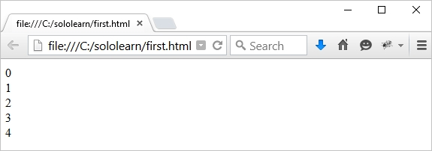

**Heads up!**  
You can use the return keyword to return some value immediately from the loop inside of a function. This will also break the loop.

**Continue**  
  
We're nearly done with module 3! One last thing to cover.  
  
Unlike the **break** statement, the **continue**statement breaks only one iteration in the loop, and continues with the next iteration.  
**Like this:**

for (i = 0; i <= 10; i++) {   
if (i == 5) {   
**continue;**   
}   
document.write(i + "<br />");   
}

**Result (отобразится все кроме 5 – где continue):**

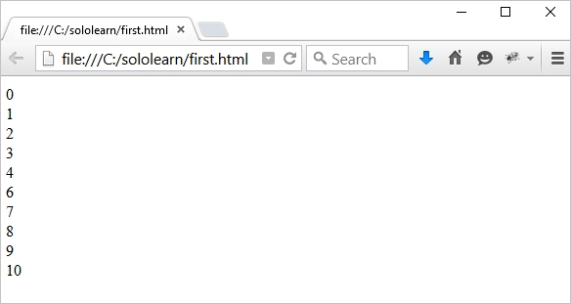

**Heads up!**  
The value 5 is not printed, because **continue**skips that iteration of the loop.